NOTES FOR DAY 17
OF "DEMONS" COURSE

SAVING NANDA MAHARAJA FROM THE SNAKE

1. The cowherd men decided to go to Ambikavana for Sivaratri (Feb-Mar). They didn't regularly celebrate it, just sometimes, in the mood of Vaiñnavas. They were going to Ambikavana out of curiosity, on the banks of the Sarasvati.

2. First they bathed in the Sarasvati, then they gave charity, did their worship. They fasted all day, then while they were sleeping a great snake (a python) tried to swallow Nanda Maharäja.

3. He called out and the cowherd men came with burning logs and hit the snake, but it still kept swallowing Nanda Maharäja.

4. Then Kåñëa came and touched the snake with His foot, and the snake gave up his body and manifested a demigod form. Kåñëa asked him how he got this form, and the demigod replied: ""My dear Lord," he said, "in my previous life I was named Vidyadhara and was known all over the world for my beauty. Because I was a celebrated personality, I used to travel all over in my airplane. While traveling, I saw a great sage named Angira. He was very ugly, and because I was very proud of my beauty, I laughed at him. Due to this sinful action, I was condemned by the great sage to assume the form of a serpent."
Çrémad Bhägavatam — He was the leader of the Vidyadharas. His name was Sudarsana.

5. Çréla Prabhupäda explains that this is a good example of someone being materially elevated but then falling down due to a mistake. So all material situations are temporary and unreliable, and one should not be attached to them or think one is highly qualified.
Çréla Prabhupäda says: "A Krsna conscious person knows that he is always the servant of the servant of Krsna; he is most insignificant, and whatever good he does is by the grace of Krsna and the spiritual master."

6, The demigod said that he now considered the curse a benediction, as due to it he had now been touched by the lotus foot of the Lord and delivered from maya.

7. Kåñëa Book says: "A snake is considered to be the most cruel and envious living entity, but those who are human beings and are envious of others are considered to be even more vicious than snakes. The snake can be subdued or controlled by charming mantras and herbs, but a person who is envious cannot be controlled by anyone."

8. Then he took permission from the Lord to return to his position in the heavenly planets.

THE ANARTHA

**** A growing sense of a type of bliss in devotional service that encourages one to want to merge with the object of devotion.

We have already discussed about the four types of anarthas. One is arising from previous pious activity. One part of that is the desire for liberation.

In Kåñëa consciousness we are not looking for relief, we are looking for service, even though sometimes in that service there may be difficulty. It is said by Sanatana Goswami in Brhad Bhagavatamrta about Goloka Våndävana: "Torment felt there dances again and again on the heads of all happinesses. Grief felt there is better than the greatest bliss."

This is said to be harder to overcome than the desire for bhukti.

In Caitanya-caritämåta, Madhya-lila 19.176 it is said:

bhukti-mukti-sprha yavat
pisaci hrdi vartate
tavad bhakti-sukhasyatra
katham abhyudayo bhavet

"The material desire to enjoy the material world and the desire to become liberated from material bondage are considered to be two witches, and they haunt one like ghosts. As long as these witches remain within the heart, how can one feel transcendental bliss? As long as these two witches remain in the heart, there is no possibiIity of enjoying the transcendental bliss of devotional service.”

In Madhya-lila 19.167 it is said:

anyabhilasita-sun yam.
jnana-karmady-anavrtam
anukulyena krsnanu-
silanam bhaktir uttama

"When first-class devotional service develops, one must be devoid of all material desires, knowledge obtained by monistic philosophy, and fruitive action. The devotee must constantly serve Krsna favorably, as Krsna desires.”

Çréla Prabhupäda explains: Many persons in the community of Siva Svami gave up the atma-nistha (devotional service) of the Lord and followed the path of Sankaracarya. (Madhya 3.6)

ÇANKHACUDA

He represents the tendency to want sense gratification in the name of devotional service.

*** See Garga Samhita 2.3 for further information about Sankhacuda (important)

Kamsa had more or less taken over the universe, and defeated all these demons. But he had not been able to defeat Sankhacuda. They fought with clubs for 28 days. Broke their clubs. Then Kamsa threw Sankha 800 miles into the sky. Sankha threw Kamsa 80,000 miles into the sky.

1. This pastime took place on Gaura-purima (Holi).

2. Both Kåñëa and Balaräma were rasa dancing with the gopis, each with Their own group.
SS — They were singing a special melody so nicely that They were covering the entire range of musical notes.

3. The gopis became completely stunned on hearing such beautiful singing. Their hair loosened, their dresses slackened, their garlands fell to the ground.

4. Then Sankhacuda, a demon associate of Kuvera came and drove the gopis away to the north, while the Lords looked on.
VCT — he shook a big stick at them. He did not touch them
SRG — (gives a different account. Rädhä and Kåñëa meet while Rädhä is doing worship of the sungod. After the worship Kåñëa enthrones Rädhä on a jewelled throne, and then Sankha comes) Aristasura had advised Kamsa to marry Çrémati Rädhäräni, so Kamsa sent Sankhasura to kidnap Her. When S. was first seen, Kundalata thought he was the sungod, but Paurnamasi explained that he was a yaksa who was the leader of the guards of Kuvera's treasury. He saw the gem in the treasury, liked it, so stole it. He had fearsome, curling fangs.

5. They called out to Kåñëa and Balaräma to rescue them, and They ran in pursuit. Then Sankhacuda, in fear, abandoned the gopis and ran for his life. Balaräma remained with the gopis to protect them, and Kåñëa chased Sankhacuda, wanting to get the conch shaped gem from his forehead.

6. Then Kåñëa hit him with His fist and knocked his head off.

7. Kåñëa then gave the gem to Balaräma
VCT — to avoid a situation in which the gopis might become envious, thinking, "will He give it to me," Kåñëa gave it to Balaräma, and Balaräma gave it to Rädhä.

Proneness towards acquiring name and fame, and desire for sensuous enjoyment, under the plea of devotion.

FROM LALITA-MADHAVA

Jatila picks Kåñëa over Madhumangala (who wants laddus)

Kåñëa starts chanting esoteric mantras:

nibhåtam arati-puïja-bhäji rädhe
tvad-adhara-vardhita-cäpäle caläkñi
caöulaya kuöiläà dåg-anta-lakñmém
ayi kåpaëe kñaëam oà namaù savitre

Kåñëa: O worshipable sun-god, I humbly worship you. O moving eye that nourishes those beneath you, please grant the treasure of your bending sidelong glance to this poor person. I offer my respectful obeisances to you.

Note: If the word "nibhåtam" is interpreted to mean in a secluded place", "rädhe" is interpreted to mean "O Rädhä", "adhara" to mean "lips" and "capale" to mean "restless yearnings", the verse reveals the following hidden meaning:

"O Rädhä whom I worship in a sceluded place, O girl whose eyes are restless, O girl whose lips make Me restless with desire, please grant the treasure of Your crooked sidelong glance to this poor person, O Rädhä splendid as the sun, I offer My respectful obeisances to You."

Madhumangala: (laughing loudly) O elderly lady considered intelligent among the cowherd women, you may know about the riri-songs (of the gopis), but what do you know about our Vedas? Listen. This mantra, which brings auspiciousness to young girls, is found in the Third Chapter of the Kausumesavi-sakha of the Veda.
Note: Kusumesu is a name of Kamadeva. The word "kausumesavi-sakha" may be interpreted to mean: "Kamadeva's book of amorous pastimes."

The exchange continues:
arcitärcädhunä dhanye
tvaà arghyaà kuru bhävataù
ambarodbhäsine gäòhä
mudä räjéva-bandhave

(rädhä sambhramaà naöayati.)

Kåñëa: O fortunate girl, now that You have worshipped the deity, You should offer arghya-water to the sun-planet shinning in the sky. (Rädhä is reverential.)

Note: If the word "ambara" is interpreted to mean "garments", and if "gäòha-mudä räjéva-bandhave" is divided "gäòham udära-jéva-bandhave", the following hidden meaning is revealed:

"O fortunate girl, now that You have worshiped the deity, You may worship Your noble life's friend, who stands before You dressed in glittering (yellow) garments."

Text 38

kundalatä: (sanskåtena)

sanskåtena—in Sanskrit; samprati—now; kanya-raseù—of the sign of the zodiac named Virgo; upabhogam—staying in the same place; kurvate—does; purah-sthaya—in the presence; mitraya—to the sun; citram—wonderful; arghyam—arghya; kuru—please do; su—beautifully; smita—blossomed; pundarikena—with a lotus flower; rädhä—Rädhä; drk—of the eyes; antena—with the corner; harim— at Kåñëa; paçyati—looks.

Kundalatä: (in Sanskrit) The sun is now in the sign Virgo. Now You should offer him wonderful arghya-water with a beautiful blossoming blue lotus flower. (Rädhä glances at Kåñëa from the corner of Her eye.)

Note: If the word "kanyä" is interpreted to mean "young girls", "räçeù" to mean "of a multitude", "upabhogam" "enjoyment", miträya" "friend", and "smita" smile", the verse reveals the following hidden meaning:

"Your friend, who is expert at enjoying (amorous pastimes) with many young girls now stands before You. Now You should offer Him wonderful arghya with the beautiful blossoming blue lotus flower of Your smile"

Then Madhumangala insists on a feast as payment, and Jatila agrees. He blesses her:
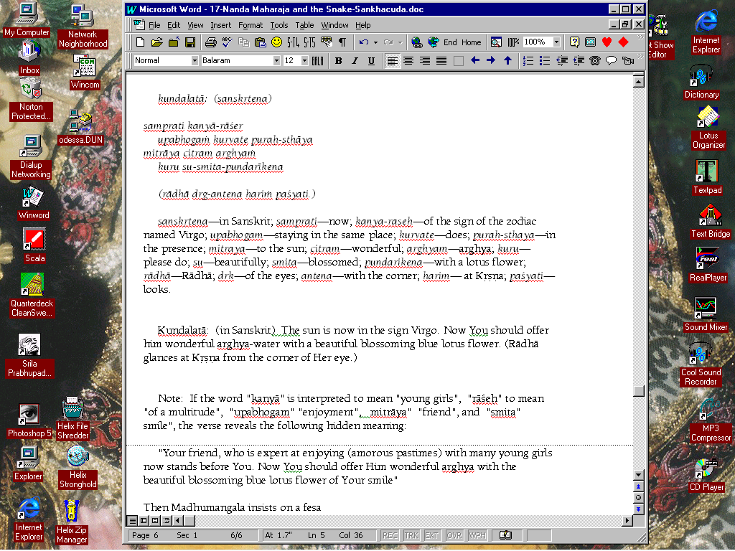
Madhumangala: (happily) O noble lady, because you wish to offer a delicious feast to the brahmanas, (I bless you that) you will become the mother of many sons.

Çréla Rüpa Goswämi: Mukhara (Rädhä's grandmother) comes on the scene and sees Rädhä and Kåñëa together and is upset ("Ah! A great misfortune! Why has this kalpa-lata creeper abandoned a sandal tree to rest on this castor-oil plant?")

Then Kåñëa runs away to hide in a grove, but Mukhara follows Him. She is half blind so she can't see Him, so she looks where Sankha is hiding, and thinks that Kåñëa has assumed this disguise. Then Sankha jumps out, grabs Rädhä and runs off.

Kåñëa then appears and offers to rescue Çrémati Rädhäräni, and Mukhara is now very happy with Him. Kåñëa says: (with chivalrous pride) "Wicked demon offensive to Sri Radha, I feel great pain because I cannot spend eternity torturing you. The wicked black night of death now chases you, covering you with all it's limbs. How will I (torture you forever if you merely die)?" Then He catches him and punches him to death.

